Big Mountain Resort has excellent facilities, beautiful views, and accommodates about 350,000 guests every ski season. The current price for an adult weekend ticket is $81. Resort leadership have been considering increasing the base ticket price to increase revenue. Additionally, they have proposed the following options to further increase profit margins: closing the 10 least used runs, increasing the vertical drop (requiring a new chair lift), adding 2 acres of snow-making machine coverage, and increasing the longest run to 3.5 miles in length (requiring 4 more acres of snow-making machine coverage).

The provided data were used to construct a random forest model that predicted ticket price based on available facilities at other resorts. When given Big Mountain’s facilities data as input, the model predicted a ticket price of $97.96, with error margins from $88 to $108. This suggests that Big Mountain is significantly undercharging their clientele relative to the national market. A representative sample of different features are shown below, where Big Mountain is marked with a dashed red line:

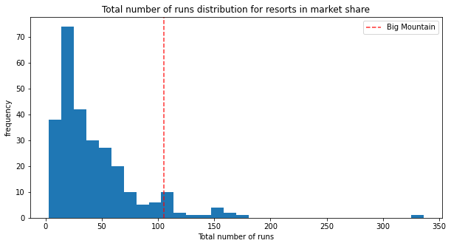

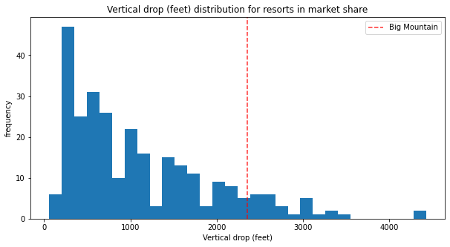

The proposed revenue-increasing solutions were also evaluated with the model. Closing 10 runs would decrease the projected ticket price by almost $3, and significantly impact revenue per guest, as shown in the below figure: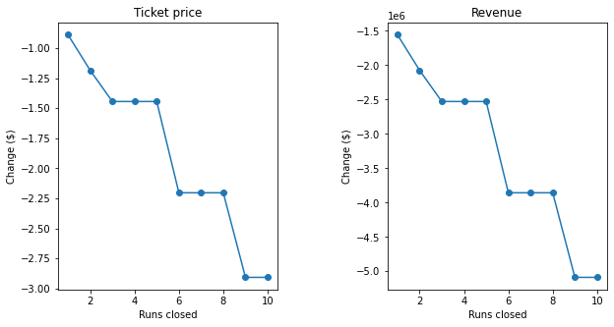

Increasing the vertical drop by 150 feet and installing a chair lift would support a ticket price approximately $2.22 higher than the original projected one, increasing revenue by about $3.88 million over the season. Adding a few acres of snowmaking machine coverage and increasing the length of the longest run by 0.2 miles did not affect the projected ticket price of the model.

My recommendations are that Big Mountain increase the vertical drop while also increasing the ticket price. Based on the national market, the facilities offered by Big Mountain justify increasing the ticket price by at least $7, which will increase to $9 after the vertical drop is increased and the chair is added. Based on an operating cost of $1.54 million per chair, the cost should be offset by the increased revenue. I cannot recommend closing the 10 least used runs because I do not have operating cost information for them; however, losing $5 per customer due to the required decreased ticket price leads to a revenue loss of $1.75 million.

One important point that should be taken into consideration when setting a new ticket price is that Big Mountain is already the most expensive ski resort in Montana. It is important to consider the local market as well as the national market, and also how far customers typically travel to Big Mountain. It may be necessary to increase the ticket price by slightly less than the model suggests in order to stay competitive in the local market.